# IoT node design

## Overview

The Internet of Things (IoT) node is a combination of a microcontroller and hardware sensors that is installed in a GrowCube to record data automatically. This document describes the proposed components and associated costs.

## Microcontroller

The main requirements for the microcontroller are to

* provide connections for an appropriate range and number of sensors
* communicate over WiFi
* provide user interaction and feedback
* operate independently of a fixed power supply
* enable the local storage of data
* consume as little power as possible
* have a small physical footprint

The device selected is the [LilyGo TTGO T5](http://www.lilygo.cn/prod_view.aspx?TypeId=50061&Id=1393&FId=t3:50061:3) (Figure 1) which includes an e-paper display, programmable button and an integrated SD card reader.

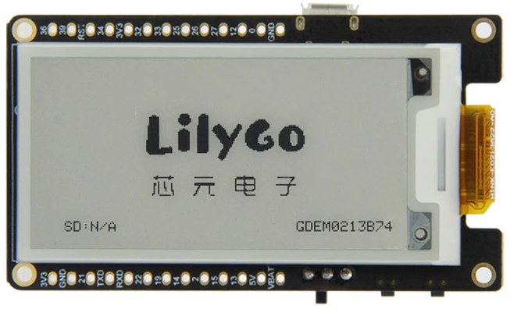

66.3mm

36.8mm

e-Paper display

Programmable button

Reset button

Power switch

Micro USB

Figure 1: TTGO T5 microcontroller

The device will be packaged in a 3D printed enclosure (see below) that will protect the electronics while providing access to the controls shown in Figure 1 and for making connections to the sensors.

## Sensors

The proposed parameters that the IoT node will measure are

* Air temperature
* Relative humidity
* Light intensity
* Barometric pressure
* Water level
* Substrate pH
* Substrate electrical conductivity
* Substrate moisture
* Substrate temperature

The following sections provide details of the recommended sensors in each case.

### Air temperature and relative humidity

These two quantities are often measured by a single device and the recommended option for this project is the [Sensirion SHTC3](https://www.sensirion.com/en/environmental-sensors/humidity-sensors/digital-humidity-sensor-shtc3-our-new-standard-for-consumer-electronics/). This sensor is pre-calibrated and provides an accuracy of ±2% for relative humidity and ±0.2°C. It comes packaged in various ways, and the one shown in Figure 2 is mounted on a circuit board with a mounting hole. This is the version that would be used if the sensors are individually enclosed. Please see the ***Enclosures*** section for further details.

Figure 2: Packaged SHTC3 temperature and humidity sensor

### Light intensity

The proposed sensor for light intensity is the [Rohm BH1750FVI](https://datasheetspdf.com/pdf-file/679289/Rohm/BH1750FVI/1) which provides output in lux (lx) with an accuracy of ±1.2 lx. For reference, ambient daylight typically ranges between 10000 and 25000 lx. The sensor is pre-calibrated and comes packed as the GY-30 board shown in Figure 3.

Figure 3: GY-30 light intensity sensor board

### Barometric pressure

As well as any potential direct influences on plant growth, a measurement of ambient pressure is required for an accurate assessment of the water level measurement (see below). The sensor selected is the GY-BMP280 (Figure 4) which includes temperature compensation of the pressure reading.

Figure : GY-BMP280 barometric pressure sensor

### Water level

This sensor assumes that the GrowCube will have a reservoir of water for each level that is independent of the individual seedling locations. It essentially duplicates the on-board water level gauge. The device proposed depends on changes in pressure as the depth of water increases. The pressure sensor shown in Figure 5 will be equipped with a piece of flexible tube that will be submerged in the water. Calibration is required. This type of sensor is preferred over a resistive sensor to avoid issues with corrosion of the metal traces.

Figure 5: Pressure sensor for measuring water depth

### Substrate moisture

There are two main types of moisture sensor. The resistive type depend on the resistance between exposed metal traces and are prone to corrosion. The capacitive type do not have exposed electrical connections, and are usually preferred. The model proposed here, shown in Figure 6, is built using the Texas Instruments TL555I timer chip which allows the device to work at a voltage that is compatible with the T5. This sensor requires calibration.

Figure 6: Capacitive soil moisture sensor

### Substrate temperature

The temperature of the growing substrate may differ from the ambient air temperature. The device based on the [Maxim DS18B20](https://datasheets.maximintegrated.com/en/ds/DS18B20.pdf) digital thermometer chip shown in Figure 7 is pre-calibrated.

Figure 7: DS18B20 waterproof soil temperature sensor

### Substrate pH

Typical pH sensors are relatively expensive in comparison to the other sensors above. They are composed of a probe and a signal processing board that are linked by a cable. One of the most popular pH sensors available is the [Gravity kit](https://www.dfrobot.com/product-2069.html) which costs around £26. A second issue with standard pH probes is that they are around 200mm in length which would not fit comfortably inside the GrowCube. Finally, the majority of pH sensors operate at 5V whereas the T5 operates at 3.3V.

Zimmer and Peacock (Z&P) offer a [solid state pH probe](https://www.zimmerpeacocktech.com/products/electrochemical-sensors/ph-sensor/) which is much smaller (25.4 x 7 x 0.625 mm) and cheaper than the standard ones. However, use the Z&P probes would entail the construction of bespoke connection cables based on the BNC adapter shown in Figure 8.

An installed pH sensor would consist of the items listed below and pictured in Figure 8 including a signal processing board from a Gravity kit. These sensors would require calibration using solutions of known pH.

1. Z&P solid-state probe
2. Connection clip
3. BNC cable (to be modified after delivery)
4. Signal processing board

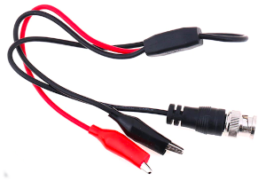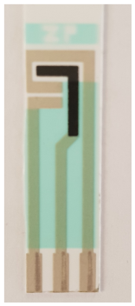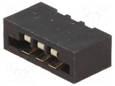

a

b

c

d

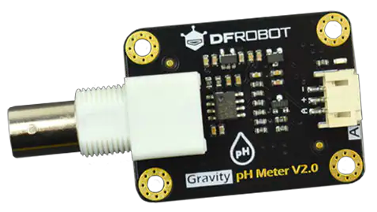

Figure 8: pH sensor components

### Substrate electrical conductivity

The electrical conductivity (EC) of a substrate can be measured easily by measuring the resistance between two electrodes. The device shown in Figure 9 incorporates a waterproof probe and signal processing board.

Figure : EC meter

### Costs

The estimated costs per unit for each of the sensors described above are shown in Table 1. These figures are based on information available at the time of writing and include costs for shipping, customs and VAT where relevant. The total cost for three sets of sensors in each of 138 GrowCubes comes to £15760.58 Please note that this figure is for the sensors only and does not include other hardware costs such as the T5 microprocessors, enclosures, batteries, etc.

Table 1: Sensor costs

|  |  |  |
| --- | --- | --- |
| Sensor | Cost per unit (£) | Link |
| SHTC3 | 1.97 | https://www.aliexpress.com/item/1005003511936737.html |
| GY-30 | 0.87 | https://www.aliexpress.com/item/33004793427.html |
| GY-BMP280 | 0.50 | https://www.aliexpress.com/item/1005003235396906.html |
| Water level | 3.97 | https://www.aliexpress.com/item/1005003611356087.html  https://hilltop-products.co.uk/cable-sleeving-protection/rubber-tubing/silicone-rubber-tubing-products/silicone-rubber-tubing-sleeves.html |
| Moisture | 0.47 | https://www.aliexpress.com/item/4001131897353.html |
| DS18B20 | 1.00 | https://www.aliexpress.com/item/1005003379804834.html |
| pH | 26.23 | https://www.zimmerpeacocktech.com/products/electrochemical-sensors/ph-sensor/  https://www.aliexpress.com/item/4000203388759.html  https://www.dfrobot.com/product-1782.html  https://www.aliexpress.com/item/1005002529535170.html |
| EC | 9.21 | https://www.dfrobot.com/product-1662.html |

## Electrical requirements

The T5 is powered by a 1000mAh lithium polymer (LiPo) battery which would power the device for around 36 hours at maximum consumption levels – i.e. assuming constant display refreshing during that time. Between image refreshes, the display consumes no power at all, and under normal operating conditions, one battery recharge is expected to last for up to a month. Tests will be carried out during development to provide a more precise estimate.

To make maximum use of the input/output pins on the T5, the sensor group on each of the three levels will share the same data connections. The T5 will select the sensor group for reading by controlling the power to that level. That is, while the sensors on the top level are powered, the sensors on the other two levels will not be powered. Power to a cube level will be provided by a GPIO pin on the T5 which has a maximum current capacity of 12 mA. Because some of the sensors specified require a current close to this limit, it is not possible to power them all at the same time. To work around this issue, the sensors on each level will be divided into three sets. Each set will be powered on independently in order to take the required readings. In total, then, this will require six power connections, one to activate each level, and one to activate each set within a level. The combination of the two signals will be used to power the relevant sensors. To achieve this, the cube level power signals will be controlled by a set of three jumper switches on the sensor board. The power to a sensor group will be controlled by an n-channel MOSFETs such as the one shown in Figure 10.

Figure 10: 2N7000 n-channel MOSFET

Using the approach outlined above, the three sensor sets shown in Table 2, Table 3 and Table 4 can be defined. Note that I2C is a hardware communications standard whereby several sensors share the same two connections. These are accounted for separately in Table 5 and therefore any I2C sensors are shown with a pin requirement of zero.

Table 2: Sensor set 1

|  |  |  |  |
| --- | --- | --- | --- |
| Sensor | Current (mA) | Connection pins | Type |
| GY-30 (Light intensity) | 0.19 | 0 | I2C |
| GY-BMP280 (barometric pressure) | 0.18 | 0 | I2C |
| SHTC3 (Temperature, humidity) | 0.9 | 0 | I2C |
| Electrical conductivity | 6.0 | 1 | Analogue |
| Totals | 7.27 | 1 |  |

Table 3: Sensor set 2

|  |  |  |  |
| --- | --- | --- | --- |
| Sensor | Current (mA) | Connection pins | Type |
| Substrate moisture | 5 | 1 | Analogue |
| Substrate temperature | 1.5 | 1 | Digital |
| Totals | 6.5 | 2 |  |

Table 4: Sensor set 3

|  |  |  |  |
| --- | --- | --- | --- |
| Sensor | Current (mA) | Connection pins | Type |
| pH | 10 | 1 | Analogue |
| Totals | 10 | 1 |  |

The complete set of connections required between the T5 and the three sensor groups are shown in Table 5.

Table 5: Pin assignments

|  |  |  |  |  |
| --- | --- | --- | --- | --- |
| T5 pin no | Purpose |  | T5 pin no | Purpose |
| 0 | Level 1 select |  | 22 | I2C SCL |
| 12 | Level 2 select |  | 21 | I2C SDA |
| 27 | Level 3 select |  | 36 | Digital input 1 |
| 26 | Sensor set 1 select |  | 19 | Digital input 2 |
| 25 | Sensor set 2 select |  | 32 | Analogue input |
| 33 | Sensor set 3 select |  | GND | Common ground |

Based on the figures in Table 5, the connecting cable requires 12 cores. To allow for unforeseen requirements, a 16-core ribbon cable will be used which includes two spare channels and UART tx and rx in addition to the connections shown in Table 5. A further requirement on the cables is that they can be detached from the two enclosures for transportation and installation.

## PCBs

A printed circuit board (PCB) is required for each T5 enclosure and each sensor group enclosure. Both types of PCB will house a shrouded IDC header for connection of the data cable.

The T5 PCB (Figure 11) includes one spare signal pin connected to the T5 and a second spare pin that is not connected. This is to allow additional capacity for unforeseen requirements.

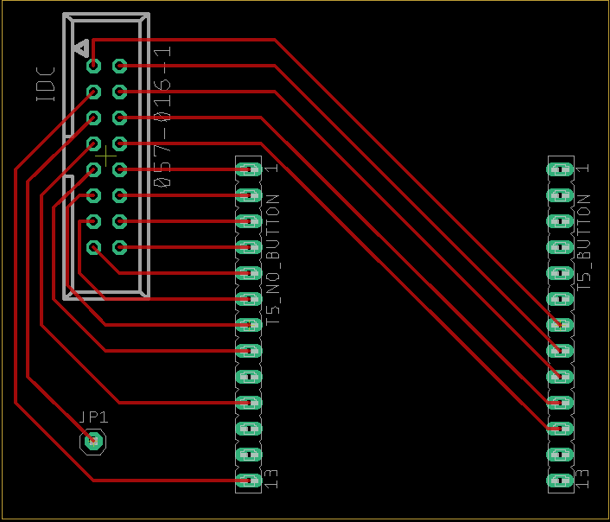

60mm

50mm

vbat

5v

13

15

2

14

19

22

tx

rx

21

gnd

3v3

gnd

0

12

27

26

25

33

32

3v3

34

rst

39

36

22

Tx

Rx

21

GND

0

12

27

19

36

-

34

32

33

25

26

Data 2

Data 1

Spare 2

Spare 1

Analogue

Set 3

Set 2

Set 1

SCL

SDA

Level 1

Level 2

Level 3

Correspondence between T5 pins and cable connector positions.

Figure 11: T5 PCB layout

The sensor PCB (Figure 12) will house a set of three jumper switches for level selection and a MOSFET for each sensor set. Each MOSFET is accompanied by a 47kΩ pull-down resistor to avoid false signals. In addition to the connections listed in Table 5, the sensor PCB breaks out the UART TX and RX connections to the T5, two spare signal pins that can be configured in software and power and ground connections for each sensor set. This is to provide extra capacity for unforeseen requirements.

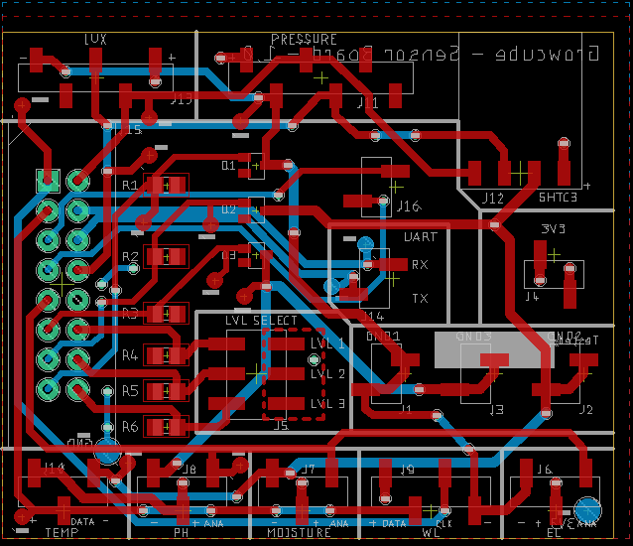

55mm

Light sensor

45mm

Switch MOSFET for set 1 (with pull-down resistor)

Switch MOSFET for set 2 (with pull-down resistor)

Switch MOSFET for set 3 (with pull-down resistor)

Pressure sensor

Temperature/humidity sensor

Jumper switch for cube level selection

Water level sensor

EC sensor

Moisture sensor

pH sensor

Temperature sensor

Cable connector

Figure 12: Sensor PCB layout

The sensor PCB is double-sided to accommodate a more complex set of connections that the T5 PCB. In Figure 12, traces printed in the top of the board are shown in red and those on the bottom are shown in blue.

## Modifications to board design

After resolving several issues with the board design itself and the connection of sensors in the full configuration, the final system is as follows.

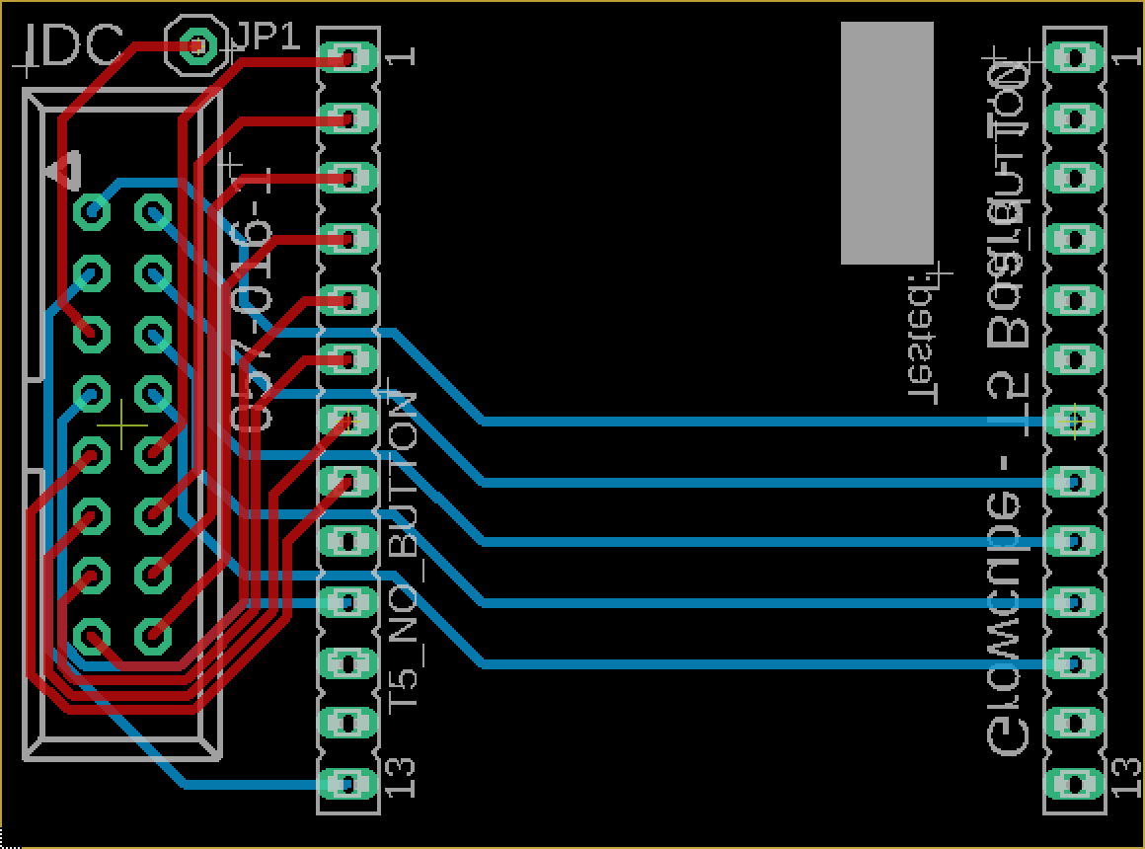

47.93mm

35.55mm

vbat

5v

13

15

2

14

19

22

tx

rx

21

gnd

3v3

gnd

0

12

27

26

25

33

32

3v3

34

rst

39

36

22

Tx

Rx

21

GND

0

12

27

19

36

-

34

32

33

25

26

Data 1

Analogue 3

3.3v

Analogue 2

Analogue 1

Set 3

Set 2

Set 1

SCL

SDA

Level 1

Level 2

Level 3

Correspondence between T5 pins and cable connector positions.

## Enclosures

The T5 microcontrollers will be housed in 3D printed enclosures similar to the one shown in Figure 13 which has been sourced from [3dmdb.com](https://3dmdb.com/en/3d-model/case-for-ttgo-t5-esp32-epaper-by-megacadler/8344093/?q=ttgo+t5+battery). The design will be adapted for the requirements of the Dandelion project.

Figure 13: Example T5 enclosure from 3dmdb.com

Each sensor group will be housed in its own enclosure with additional smaller enclosures for the pH, moisture and water level sensors. The sensor enclosures will be connected to the T5 enclosure using a 16-core ribbon cable with each sensor group connected in parallel (see next section).

## Installation

The schematic in Figure 14 illustrates the position of the microcontroller and sensors in the GrowCube.

T5 microcontroller

Sensor group

16-core ribbon cable

Cable-mount male IDC connector

750mm

750mm

Figure 14: Schematic representation of GrowCube installation

There are several aspects of the physical installation that can only be finalised once an example GrowCube is available. This mainly refers to the length and precise route of the data cables. Figure 15 shows the layout for the sensor group in the middle layer of the GrowCube. In order to avoid congestion at the back of the cube, the position of the sensors will be offset so that they appear in position B1 in the top layer and D1 in the bottom layer. The patches shown are approximately 14x14cm giving 25 patches per layer with one of those taken up by the sensors. Patches may be combined in different ways for different experiments. For example, an experiment with one factor and three levels (e.g. Physical touch: no touching, gentle tickling, moderate tickling) would require three groups of plants. Each group could be confined to a single patch to leave room for other experiments. Alternatively, each group could occupy eight patches to fill an entire tray.

**Sensors go here**

BACK

FRONT

A

B

C

D

E

1

2

3

4

5

Figure 15: Layout of sensors and growing patches in the middle layer

## Data transfer

For security reasons, data transmission from the IoT nodes will be one-way. That is, only traffic from the nodes to the server will be permitted and not in the other direction. Transmissions are also encrypted using [AES 128](https://www.trentonsystems.com/blog/aes-encryption-your-faqs-answered).

The data will be formatted as JSON in the following way:

{

"timestamp": "2022-04-05T13:15:30Z",

"mac": 12:34:45:78:9A:BC,

"battery": "75",

"top": {

"quantity1": 1.23,

"quantity2": 2.34,

"quantity3": 3.45,

"quantity4": 4.56

},

"middle": {

"quantity1": 1.23,

"quantity2": 2.34,

"quantity3": 3.45,

"quantity4": 4.56

},

"bottom": {

"quantity1": 1.23,

"quantity2": 2.34,

"quantity3": 3.45,

"quantity4": 4.56

}

}

The meaning of each field in the structure is described below.

|  |  |
| --- | --- |
| Field | Explanation |
| Timestamp | The timestamp of the row of data in ISO format: <https://www.cryptosys.net/pki/manpki/pki_iso8601datetime.html> |
| MAC | The MAC address of the node. This is a hardware-level identifier used to identify the node to the app. Before data can be uploaded, the school superuser needs to associate their node’s mac address with their school through the app |
| Battery | A representation of the battery’s charge level expressed as a percentage.. |
| Top, middle, bottom | Data for the three levels of the cube |
| Quantity1, quantity2, etc | Named quantities measured by the sensors. In reality, these placeholder name will be replaced by the actual names of the quantities (‘temperature’, ‘pH’, etc.) |

## Interface

The user-facing features of the node will be accessible via a menu system that can be accessed by using the single button on the device. To make the best use of this limited interaction, the following conventions are adopted.

|  |  |
| --- | --- |
| Interaction | Description |
| Short press | Move forwards in the current menu level. On the last item in the current level, a short press will return to the first item. |
| Long press | Select current menu item. Where the current item is a sub-branch, the next item displayed is the first item in the sub-menu. Where the current item is a value option, a long press selects the option and returns to the parent menu level. |
| Double press | From a sub-menu, a double press returns to the parent item in the level above. |
| Triple press | Returns to the menu root from any point in the menu system. |

* Menu root (home display)
  + Top level
    - Most recent values
      * Calibrate water level
      * Calibrate substrate moisture
      * Calibrate pH
      * Calibrate EC
  + Middle level
    - Repeat structure for top level
  + Bottom level
    - Repeat structure for top level

The UI is laid out as follows.

250 px

128 px